STRESS-STRAIN DIAGRAM
The strength of a material is the ability of the material to withstand load without excessive deformation or failure. This is an inherent property of the material which is often determined from experiments. Accordingly, a material can have tensile strength (ability to withstand tensile stress expressed in $N/m^{2}$), compressive strength (ability to withstand compressive stress), and shear strength (ability to withstand shear stress).
One of the most common tests conducted on any material is the tension test. The test is performed in a Universal Testing Machine (UTM).
The test specimen is made as per $ASTM E8M$ as shown. The original cross-sectional area $A_{0}$ and the gauge length $L_{0}$ are noted. The ends are having bigger size near the support to avoid breaking near the ends. Sharp corners are rounded off to avoid stress concentration. | 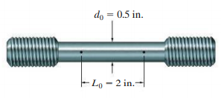
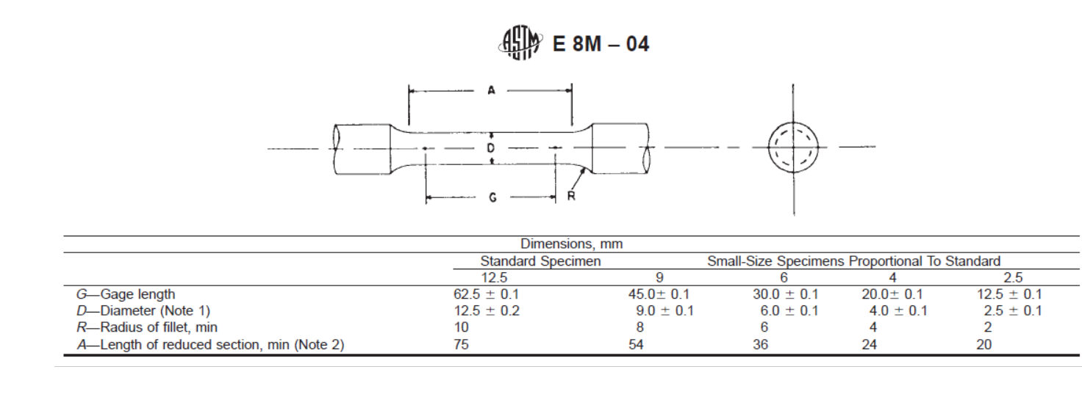
The specimen is fixed between the jaws of the UTM, the bottom one is fixed and the top one is movable. An extensometer is connected between the gauge marks. Load is applied by moving the jaw upwards. The load can be noted from the dial and the corresponding extension from the extensometer. This load and extension data can be used to plot the stress-strain diagram. |  | 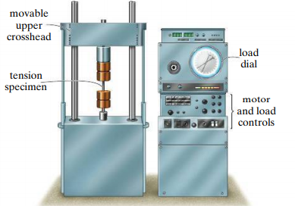

There are two types of stress-strain diagrams.
- Engineering/nominal/conventional stress-strain diagram
- True stress-strain diagram
If we divide the load by the original cross-sectional area $A_{0}$, it is called engineering stress.
Similarly, if the extension is divided by the original gauge length $L_{0}$, it is known as engineering strain. If we divide the load and extension by the cross-sectional area and gauge length at the corresponding time, we get the true stress and true strain respectively.
Let us consider a typical stress-strain diagram of a ductile material (eg. mild steel). Both engineering and true stress-strain diagrams are shown. The stress is marked along the y-axis and strain along the x-axis.  In the initial region, the stress and strain vary linearly up to a point known as proportional limit. In this region, the material is linearly elastic (or stress is proportional to strain). After the proportional limit, the curve flattens slightly and reaches a stress value known as the elastic limit. | 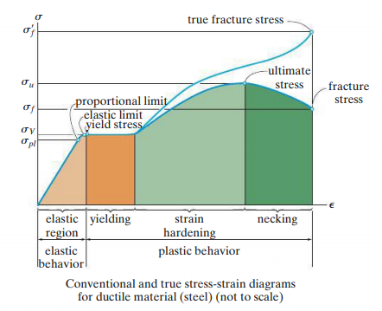
If we release the load, the specimen will come back to the original size and shape. For steel both proportional limit and elastic limit are very close. If we increase the load further, permanent plastic deformation takes place in the material. This is known as yielding. The specimen continues to deform without any additional increment of load. Slip and twinning are the two mechanisms responsible for yielding. During yielding, the atomic planes re-orient and become stable again. Afterwards, more load is required to deform the specimen further. This region is known as strain hardening region. The stress reaches maximum value known as ultimate stress.
Once the stress reaches the ultimate value, necking starts, and the cross-sectional area starts decreasing noticeably. So, the load it can withstand decreases. But we are finding the engineering stress by dividing the load value by the original cross-sectional area. Therefore, the curve comes downward and finally break. | 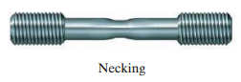  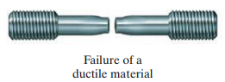

The true stress-strain diagram is also shown in the diagram. Since the area is decreasing, the stress value increases until the specimen fractures.

The failure location of the specimen exhibits cup and cone pattern which is a characteristic of most of the ductile materials. A typical stress-strain diagram of mild steel is shwn here. The proportional limit is at $241 MPa$ at a strain of around $0.0012$. The yielding begins at $262 MPa$. The strain reaches to about $0.03$ before strain hardening. The ultimate stress is $434 MPa$. The failure happens at $324 MPa$ (nominal stress). | 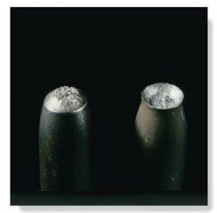
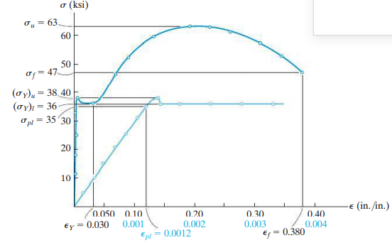
MPa
0.03
248
324
434
262
241

The strain is $0.38$ which is $317$ times the strain at proportional limit. Ductile materials undergo considerable plastic deformation before failure. Generally, the design of ductile materials is based on the Yield stress.

The percentage elongation$=\frac{L_{f}-L_{o}}{L_{o}}×100$
Percentage reduction in area $=\frac{A_{f}-A_{o}}{A_{o}}×100$

Materials like brass, zinc, molybdenum etc. exhibit similar kind of stress-strain behavior.

Many other ductile materials like Aluminium does not show well defined yield point. As mentioned above, design of ductile materials is mainly based on the yield stress, it is important to know the yield stress.
In such case, the yield stress is found out by offset method by drawing a line parallel to the initial straight line portion of the stress-strain diagram from $0.002 (0.2\%)$ strain. The value of the stress where this offset line meets the stress-strain curve is taken as the yield stress. | 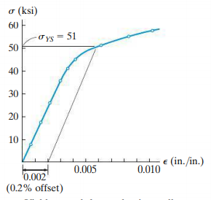  352 MPa
Natural rubber in tension  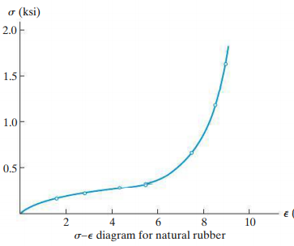 | Failure of brittle materials under torsion  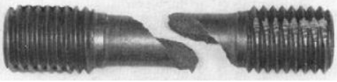  Failure of ductile materials under torsion  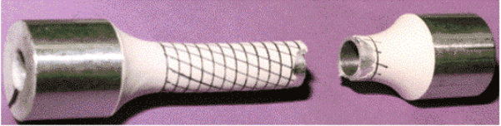  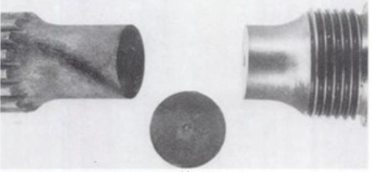

When brittle materials like cast iron is subjected to tensile test, the stress-strain diagram is like the one shown below.
Brittle materials do not undergo any plastic deformation. There will be not yielding and no necking. It fails by fracture when the stress exceeds the ultimate tensile strength. The failure of brittle materials will be sudden with no noticeable changes in shape or size. Brittle materials are weak in tension and the way it fractures is shown. | 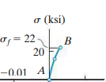  $$1 ksi=6.9 MPa$$ | 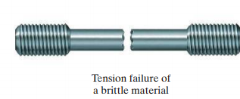

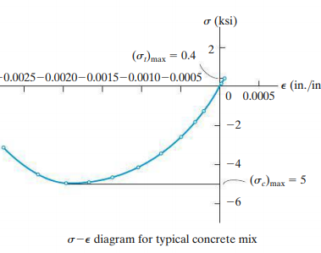 |  | 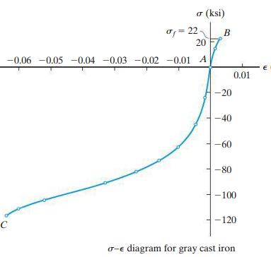
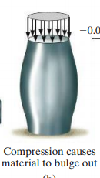 | 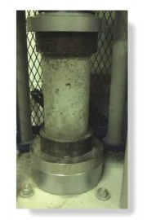 |  | 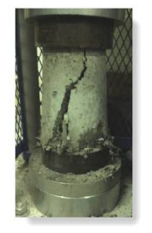  Concrete under compression

True strain
$$initial$$
$$δ$$
Consider a bar of length $L_{0}$ and cross-sectional area $A_{0}$undergoes an elongation of $δ$ due to axial force P. The engineering stress and engineering strain are,  $${σ_{e}=\frac{P}{A_{0}} ≪≫ ε}_{e}=\frac{δ}{L_{0}}$$ | $$dl$$  $$l$$  $$L_{0}$$  $$intermediate$$  $$final$$
But, when the force is applied, the bar deforms gradually. Let the final length and cross-sectional area be $L$ and $A$ respectively. Consider an intermediate position. Let $l$is the current length of the specimen. If a small increment $dl$ happens to the specimen, then the infinitesimal strain
$$dε=\frac{dl}{l}$$
The true strain,
$$ε_{t}=\int_{L_{0}}^{L}{dε}=\int_{L_{0}}^{L}{\frac{dl}{l}}=ln\frac{L}{L_{0}}=\ln\left(\frac{L_{0}+δL}{L_{0}}\right)=\ln\left(1+\frac{δ}{L_{0}}\right)=\ln\left(1+ε_{e}\right)$$
The true stress is,
$$σ_{t}=\frac{P}{A}=\frac{P}{A_{0}} \frac{A_{0}}{A}=σ_{e}\left(\frac{A_{0}}{A}\right)$$
Since, there is no loss of material during deformation, the volume remains the same.
$$A_{0}L_{0}=AL ≫≫ \frac{A_{0}}{A}=\frac{L}{L_{0}} ≫≫ \frac{A_{0}}{A}=1+ε_{e}$$
$$σ_{t}=σ_{e}\left(1+ε_{e}\right)$$
Hooke’s Law
The stress-strain diagram of most of the engineering materials will exhibit a linear relationship in the beginning till the proportional limit. As a result, an increase in stress produces a proportionate increase in strain. This was discovered by Robert Hooke and is known as Hooke’s law. Mathematically for a uni-axial loading, it can be expressed as
$$σ_{xx}=E ε_{xx}$$
The constant $E$ is known as the modulus of elasticity (Young’s modulus). It is the slope of the linear portion of the stress-strain diagram. Modulus of elasticity indicates the stiffness of the material.
The Figure shows the stress-strain diagram of iron and different grades of steel. We can notice large variations in yield strength, ultimate tensile strength, and total strain among these materials. But, the modulus of elasticity (and hence the stiffness) is the same. | 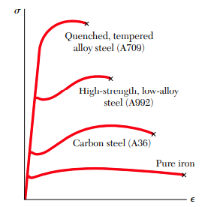

Strain Energy
When the material is stressed within the elastic limit, it regains its original size and shape up on release of the load. If we plot the load-extension curve, the area under the curve represents the work done (or energy expended) in deforming the material. This is known as the strain energy. When the load is released, the curve traces the same path back to the origin. Hence, the expended energy is recovered. |  | load  loading  unloading  extension
Strain energy= area under the load-extension diagram  $$=\int{P dl}$$  If we consider the corresponding engineering stress-strain diagram, the area under the stress-strain diagram  $$=\int{σ dε =}\int{\frac{P}{A_{0}}} \frac{dl}{L_{0}}=\frac{1}{A_{0}L_{0}}\int{P dl}=\frac{strain energy}{volume}$$ | extension  load  P  $$dl$$  strain  stress  $$σ$$  $$dε$$
The strain energy per unit volume is known as strain energy density. The area of stress-strain diagram gives the strain energy density.
Resilence is a material property that defines its ability to absorb energy without undergoing plastic deformation. The area under the elastic stress-strain region (energy absorbed per unit volume) is also known as modulus of resilience.
Toughness defines the ability of a material to absorb energy prior to fracture. The total area under the stress-strain diagram till fracture (energy absorbed per unit volume before fracture) is known as modulus of toughness.
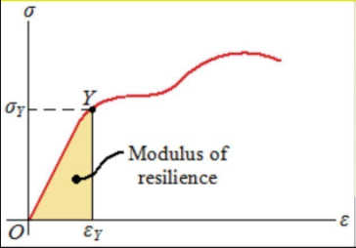 | 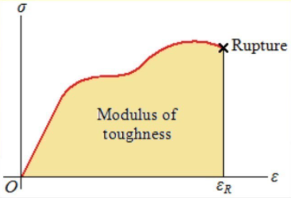
If we load the material beyond elastic limit, the curve will not trace back to origin, once the load is released. Consider the stress-strain diagram shown. Let $A$ be the elastic limit. If the material is stressed till $A’$ and released, the curve will be moving along $A’ O’$ which will be parallel to the initial straight line portion. We can see that eventhough the stress is zero, there is a strain present in the material. This strain is known as permanet set or residual strain. |  | 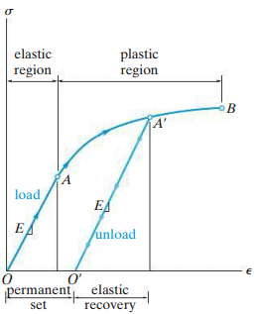

If we load the material again, the curve moves from $O’$ to $A’,$ and then to $B$. We can notice that the elastic region is increased (and hence yield strength) but the plastic region is decreased (and hence the ductlity). This is called strain hardening.
To make the residual strain zero, the material should be stressed in the opposite direction, which will then introduce a residual stress.
If we stress the material beyond the elastic limit in compression and release the load, there will be a residual compressive strain. If the cycle is repeated, a resulting hysterisis loop is obtained.  During the deformation $OAA'$, the energy expended per unit volume is the area under the curve. During unloading along $A'O$, the energy recovered in the area under $A'O$.That is, energy dissipated per unit volume is given by the area $OAA'O'O$.  Hence, the total energy dissipation during a cyclic loading is obtained by the area of the hysterisis loop. | 

The strain energy per unit volume in the linear elastic region for axial loading $=Area under the linear portion of stress-strain diagram=\frac{1}{2}σε=\frac{σ^{2}}{2E}$

Poisson’s ratio
When a material is subjected to an axial tensile force, not only its length increases but it also contracts laterally. For example, consider a cylindrical specimen of radius $r$ and length $l$, subjected to an axial tensile force. If $δl$ is the increase in length and $δr$ is the decrease in radius, the axial (longitudinal) strain is given by
$ε_{longitudinal}=\frac{δl}{l}$ and the lateral strain is given by $ε_{lateral}=-\frac{δr}{r}.$
If the material is isotropic, homogeneous, and stressed in the linear elastic range, the ratio of lateral strain to longitudinal strain bears a constant ratio known as Poisson’s ratio ($ϑ$).
Poisson’s ratio, $ϑ=-\frac{ε_{lateral}}{ε_{longitudinal}}$
It is a positive dimensionless quantity.

Shear stress-shear strain diagram
The behavior of a material subjected to pure shear can be studied in a laboratory by twisting a cylindrical workpiece. If measurements are made of the applied torque and the resulting angle of twist, the resulting shear stress and shear strain can be found out. This can be used to plot the shear stress-shear strain diagram. A typical example of a shear stress-strain diagram for a ductile is shown in figure. Like in tension test, the material will exhibit a linear elastic behavior till the proportional limit.
Then a strain hardening will occur until an ultimate shear stress is reached.
Finally, the material will begin to lose its shear strength and breaks.  For most engineering material, in the linear elastic range, Hooke’s law in shear can be written as  $$τ=Gγ$$  G is known as Modulus of rigidity or Shear modulus. The modulus of elasticity and modulus of rigidity are related by the expression (we will derive it later)  $$G=\frac{E}{2(1+ϑ)}$$ | 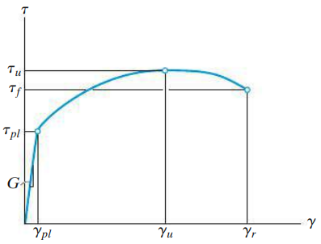

Elastic deformation of an axially loaded bar
Consider a bar of length $L$ and varying cross-sectional area, subjected to concentrated loads at the ends and a variable distributed external force along its length. Let us consider a small slice of this bar of length $dx$ at a distance $x$ from one end. The cross-sectional area of the slice be $A_{x}.$ The force acting on the element be $P_{x}.$, neglecting the very small distributed force on the element. Due to this force, the element undergoes a deformation of $dδ$. | $$P_{1}$$  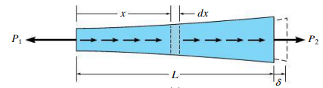  $$P_{2}$$  $$x$$  $${dx}_{ }$$ | 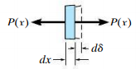  $$P_{x}$$  $$dδ$$  $${dx}_{ }$$  $$P_{x}$$
The axial stress, $σ=\frac{P_{x}}{A_{x}}$ and the axial strain, $ε=\frac{dδ}{dx}$. If the material is within the linear elastic range, by Hooke’s law $σ=E_{x} ε$
$$\frac{P_{x}}{A_{x}}=E_{x}\frac{dδ}{dx} ≫≫ dδ=\frac{P_{x} dx}{A_{x} E_{x}} ≫≫ δ=\int_{0}^{L}{\frac{P_{x} dx}{A_{x} E_{x}}}$$
If the load, cross sectional area, and elastic modulus are constant
$$δ=\frac{P}{A E}\int_{0}^{L}{dx}= \frac{PL}{AE}$$

Reference:
- Mechanics of Materials, 2/e, J. M. Gere & S. P.Timoshenko, CBS Publishers.
- Mechanics of Materials, F.P. Beer & E. R. Johnston
- Engineering Mechanics of Solids, 2/e, E. P. Popov, Pearson Education Asia.
- Mechanics of Materials, 9/e, R. C. Hibbeler, Prentice Hall.

